ANTENNA TEST REPORT

Manufacturer:
Model：
Type：External Reader Antenna

A. Specification

Electrical Specifications
Frequency | 902-928MHz
Gain | 9dBi
Beam width | Hor：70° Ver：70°
Polarization | Circular
VSWR | ≤1.4
F/B Ratio | ≥20
Impedance | 50Ω
Maximum power | 50W
Lightning protection | DC Ground
Connector | N-Female
Mechanical Specifications
Dimension | 258*258*42mm
Net weight | 0.95kg
Packing size | 40.5*30.5*10.5cm
Gross weight | 1.95kg
Radome material | ABS
Radome colour | White
Pole Diameter | Φ40-60mm
Rated wind velocity | 60m/s
Operating temperature | -40-70℃

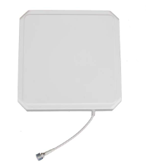

B．Engineering Drawings

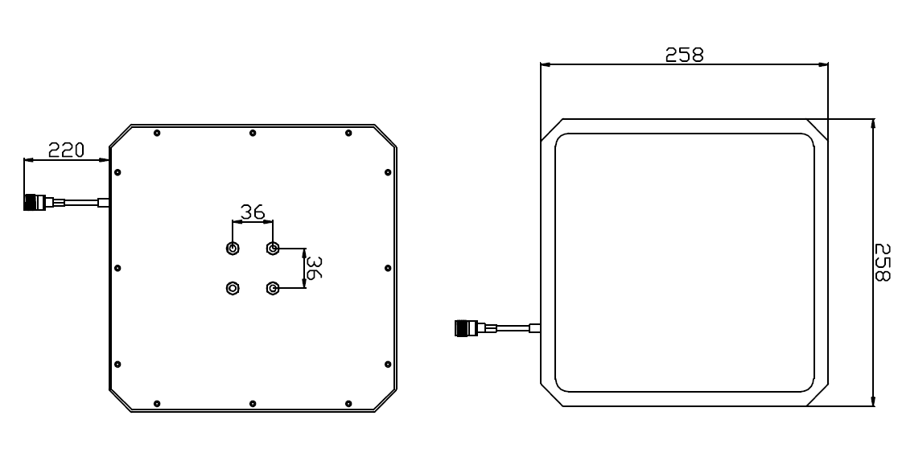

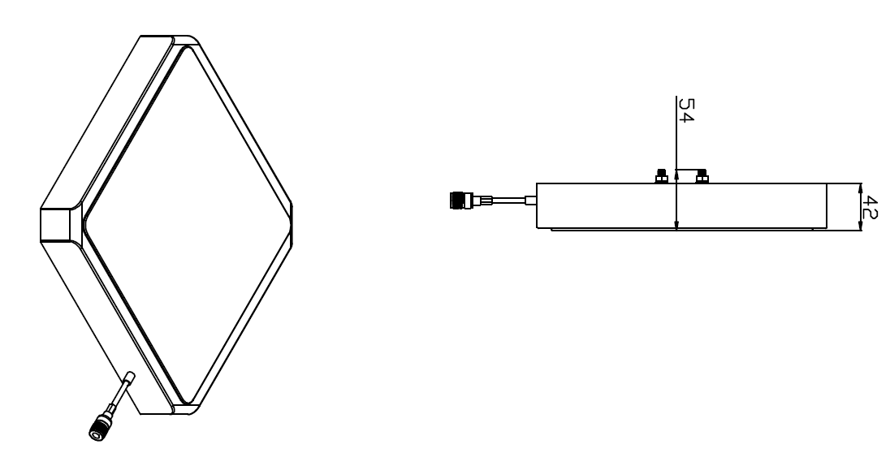

C. VSWR

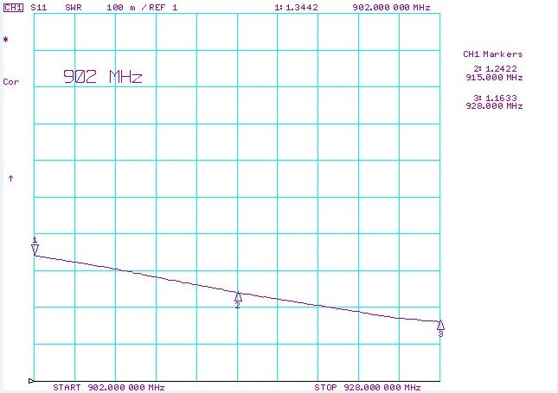

- Azimuth & gain at different frequency points.

- Frequency point：902MHz
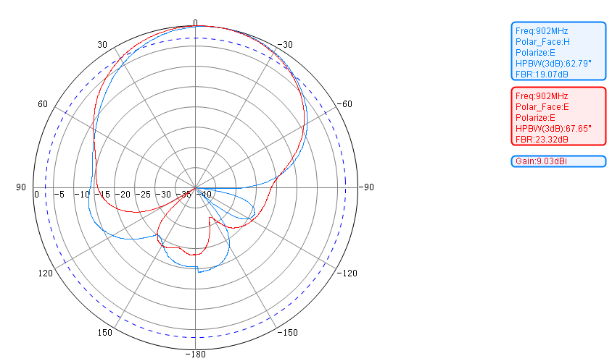

2. Frequency point： 915MHz。

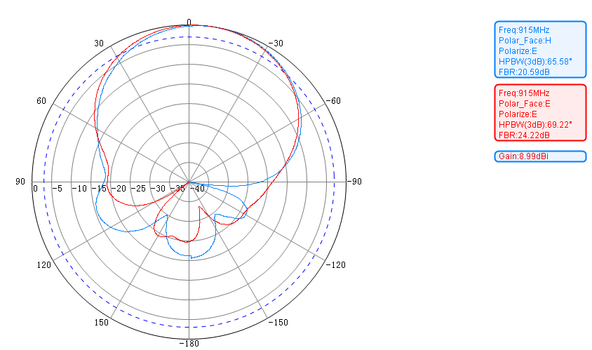

3. Frequency point：928MHz

